Online Exam Management System

User Manual

## **Before Running the Program**

After getting all the program files open in Eclipse, you are likely to be faced with a lot of errors in the code, that will prevent you from running the program. This is due to a common issue implementing the lombok library with the eclipse IDE. You only need to do this once.

1. You’ll need to go to the Maven Dependencies in your Package Explorer, and find the lombok.jar dependency. Hover over **Run As**, then click Java Application

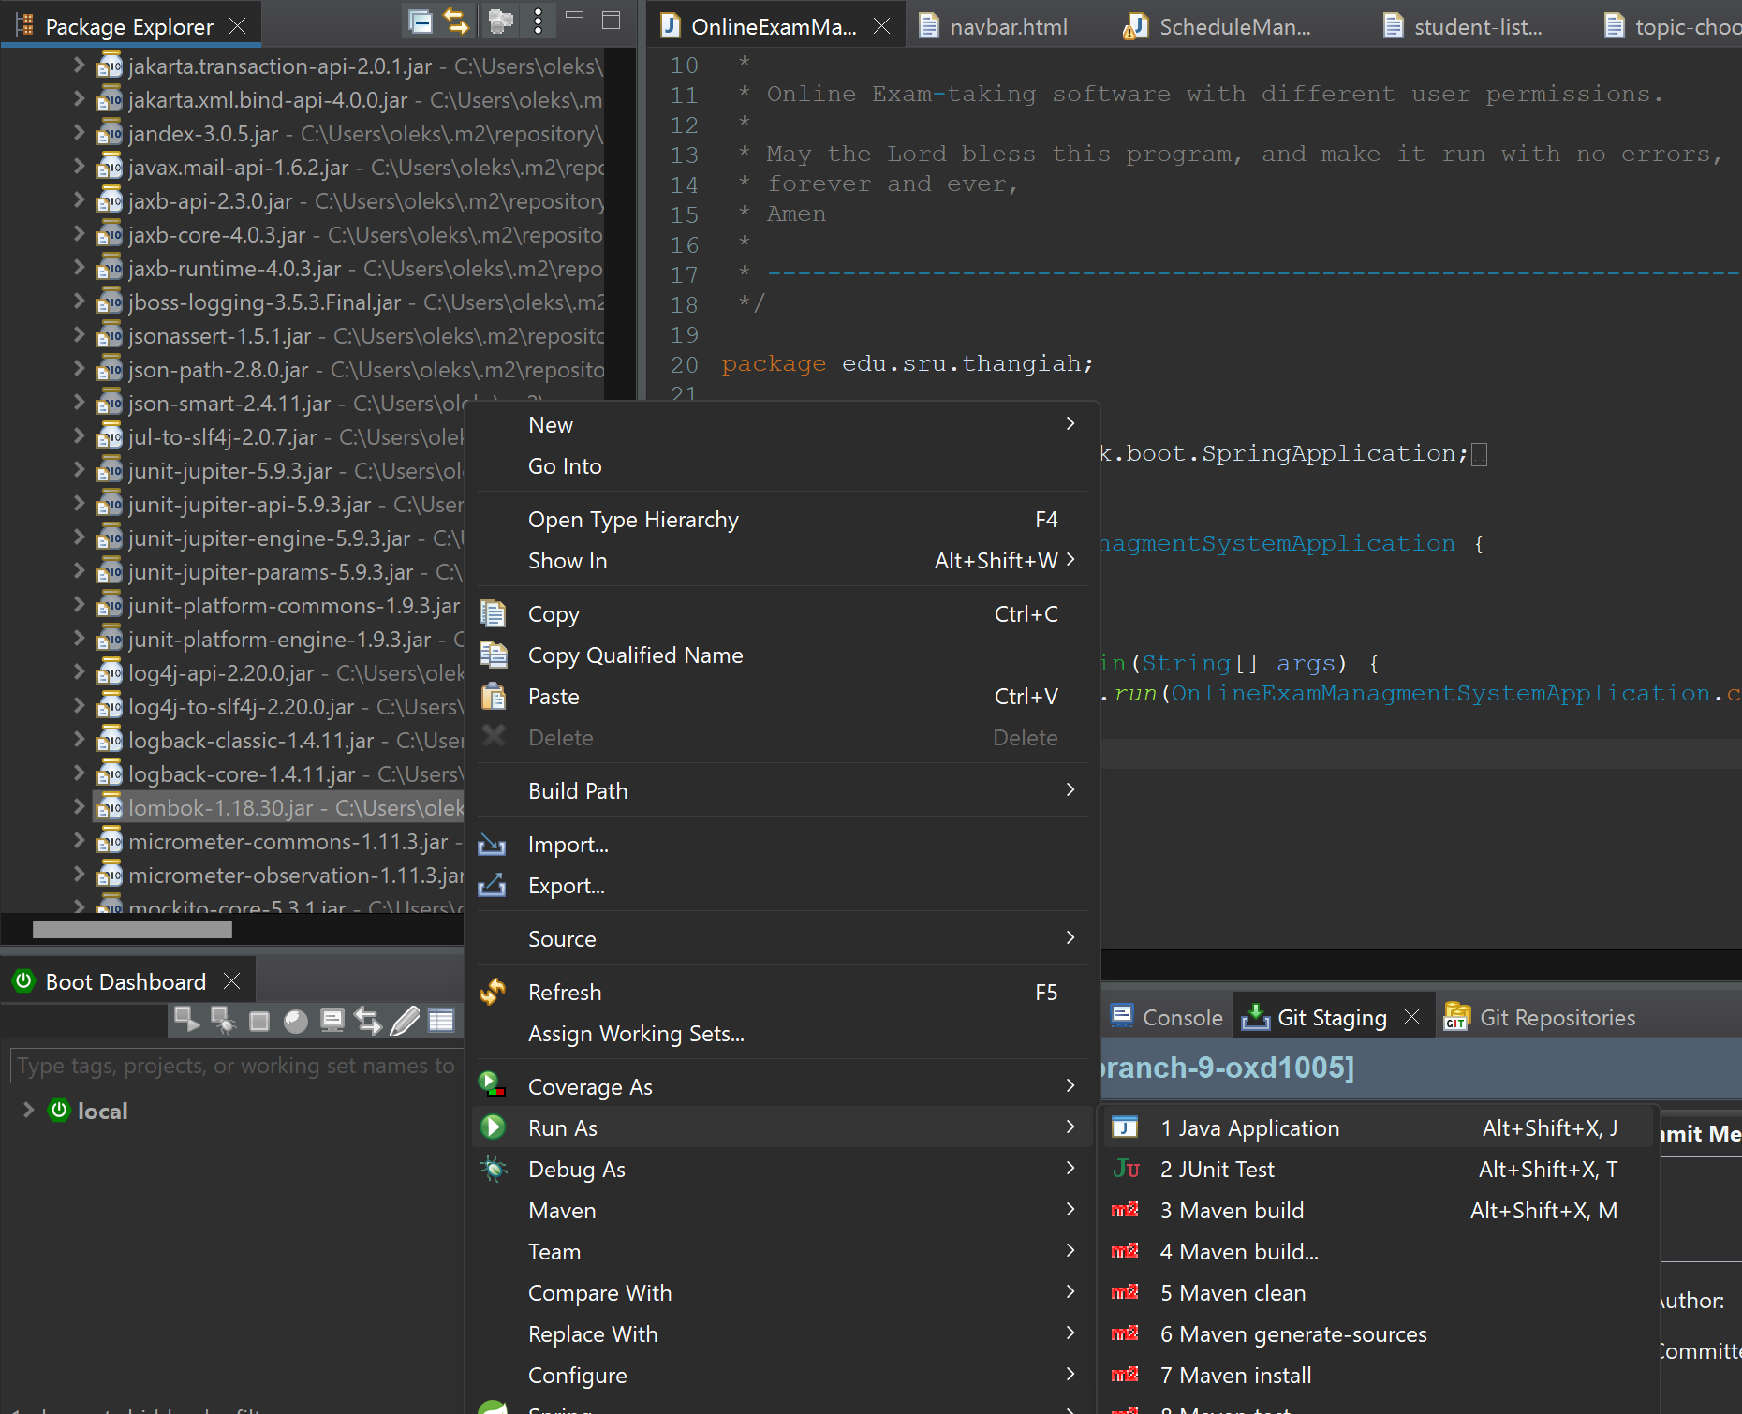

1. If error messages pop up as such, click “proceed”:

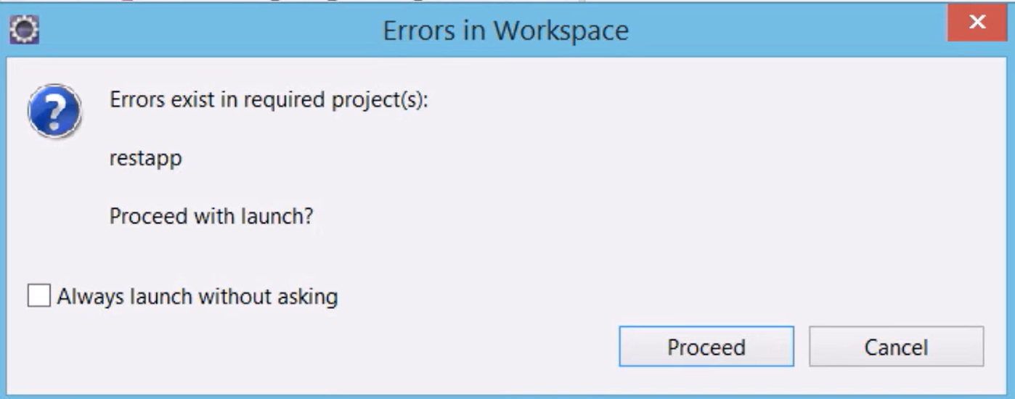

1. The lombok installer should open. Click on “Specify location…”

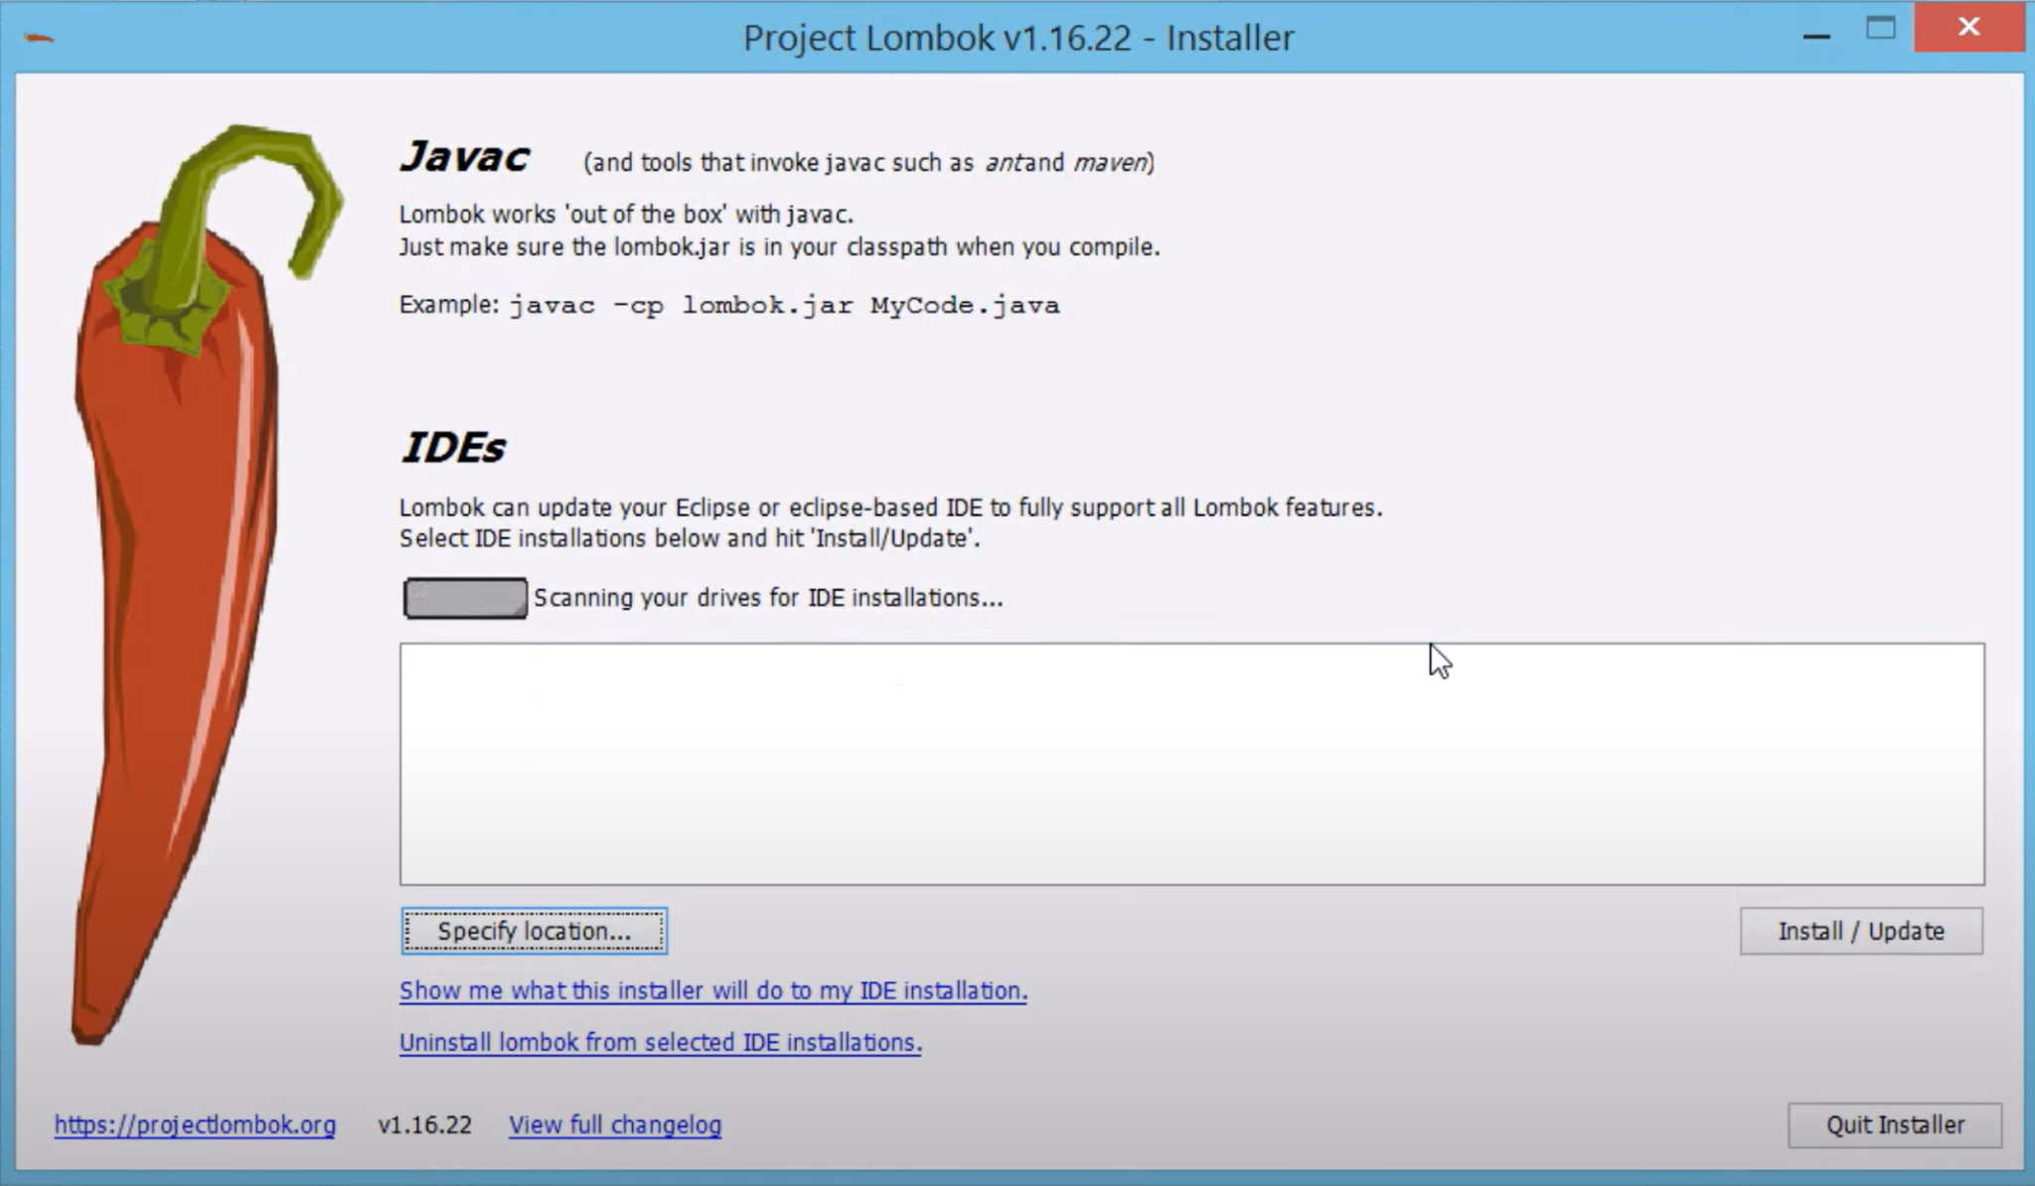

1. Go to your eclipse installation folder and select **eclipse.ini**

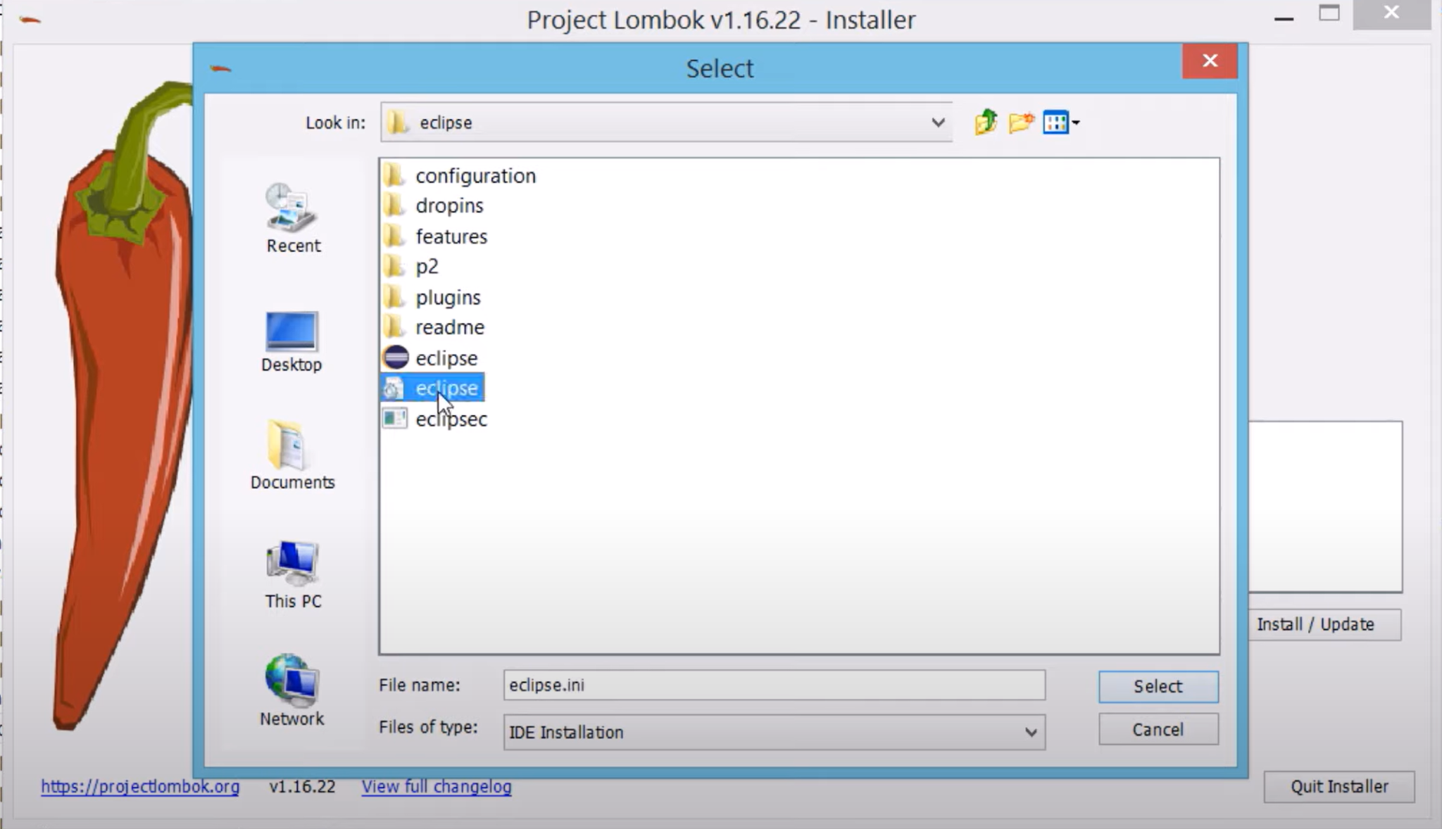

1. Click install

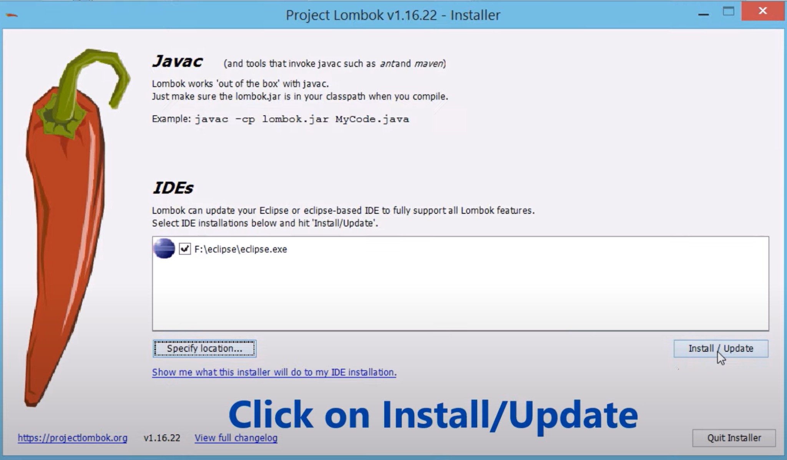

1. Click “quit installer” after the installation is complete

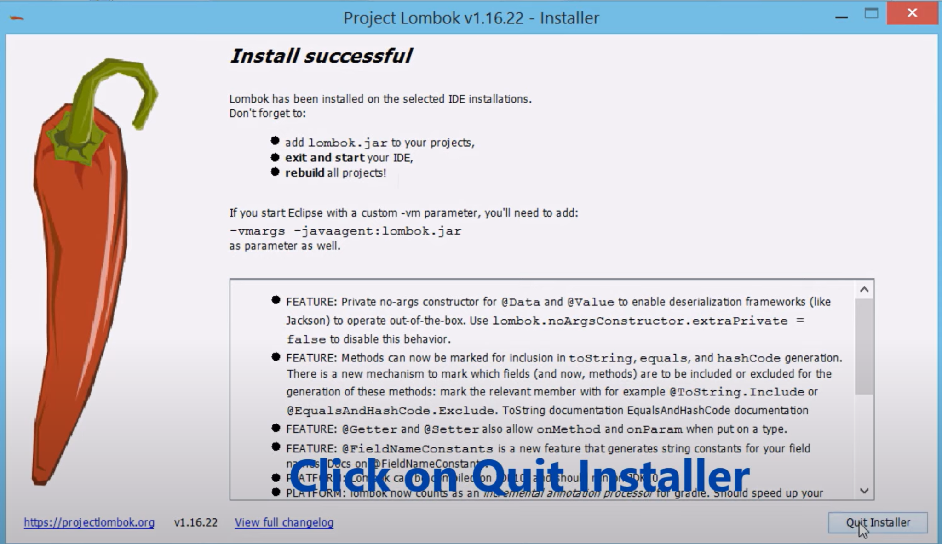

1. Go to **File** → and click **Restart**

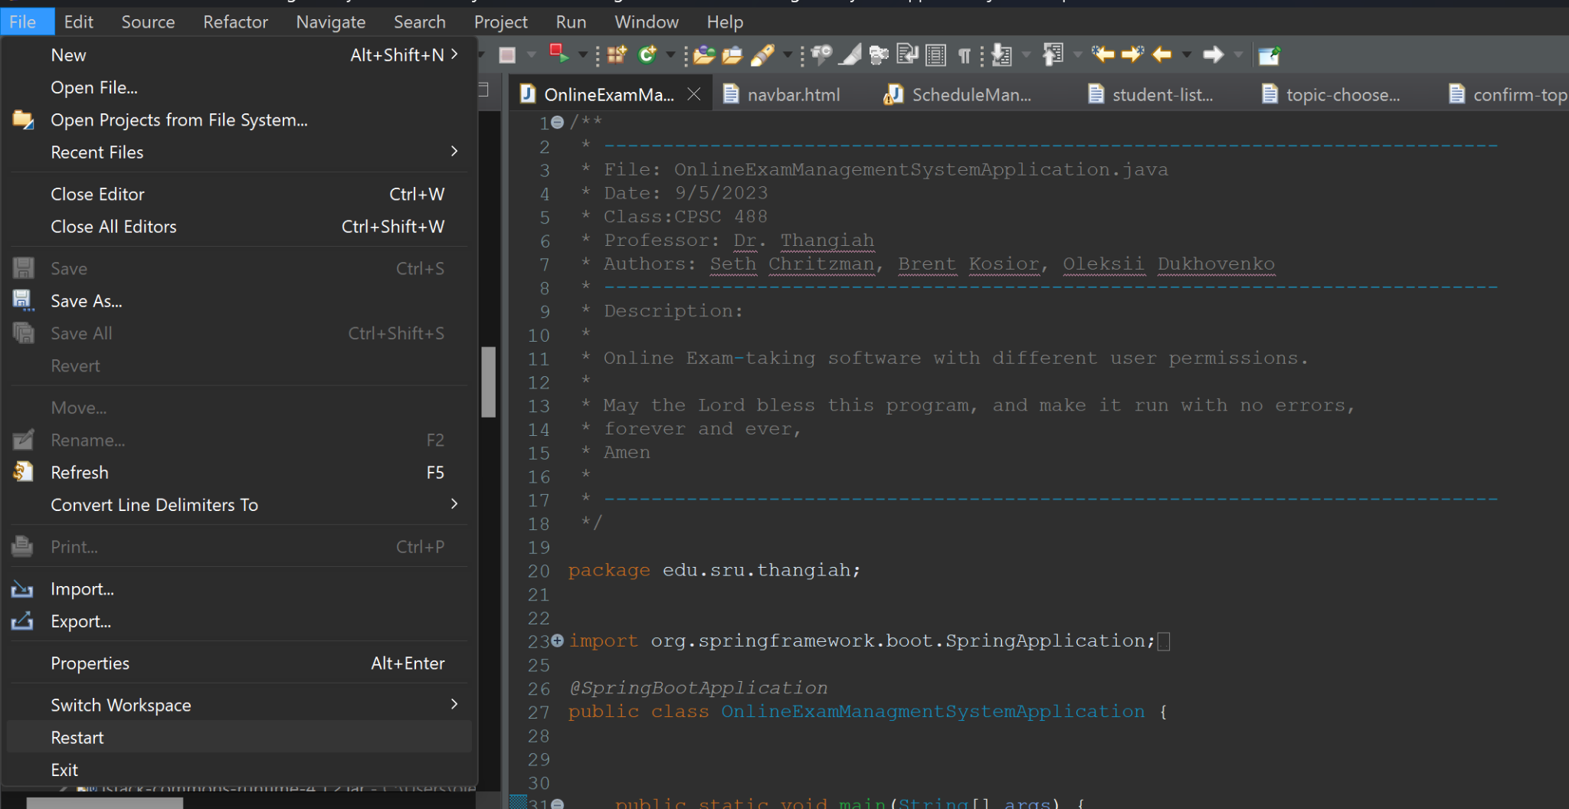

1. After Eclipse restarts, Go to **Project**→ and click **Clean**

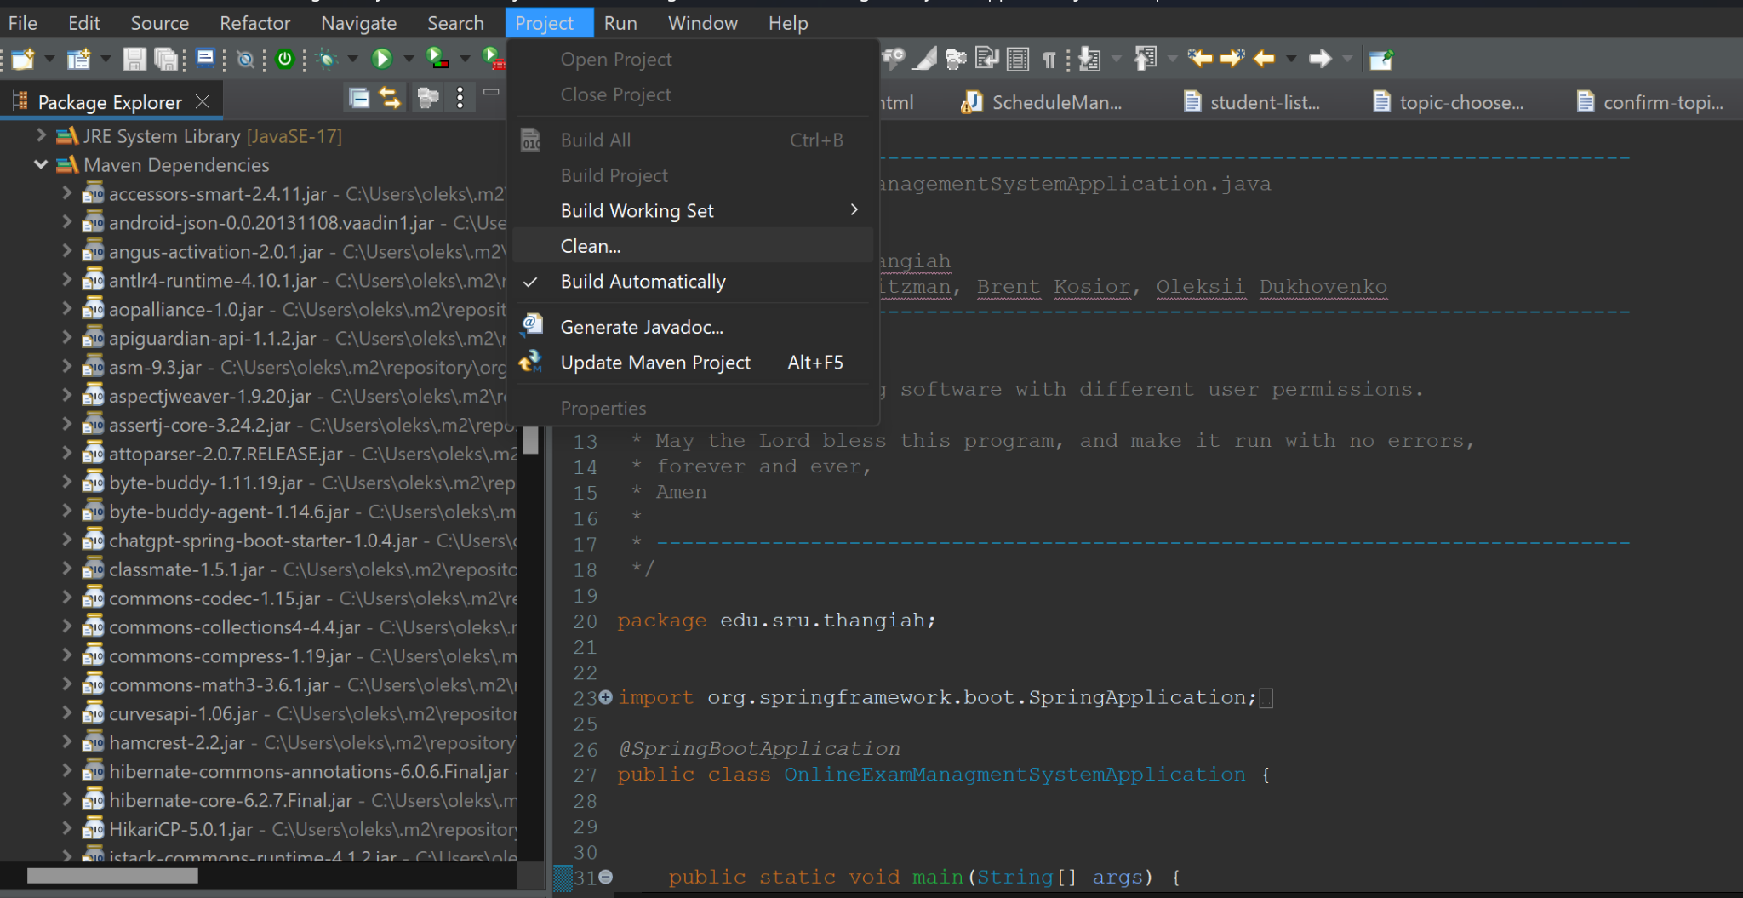

1. Uncheck ‘**Clean all projects**’ , select the **OnlineExamManagementSystem** project and click on **Clean**

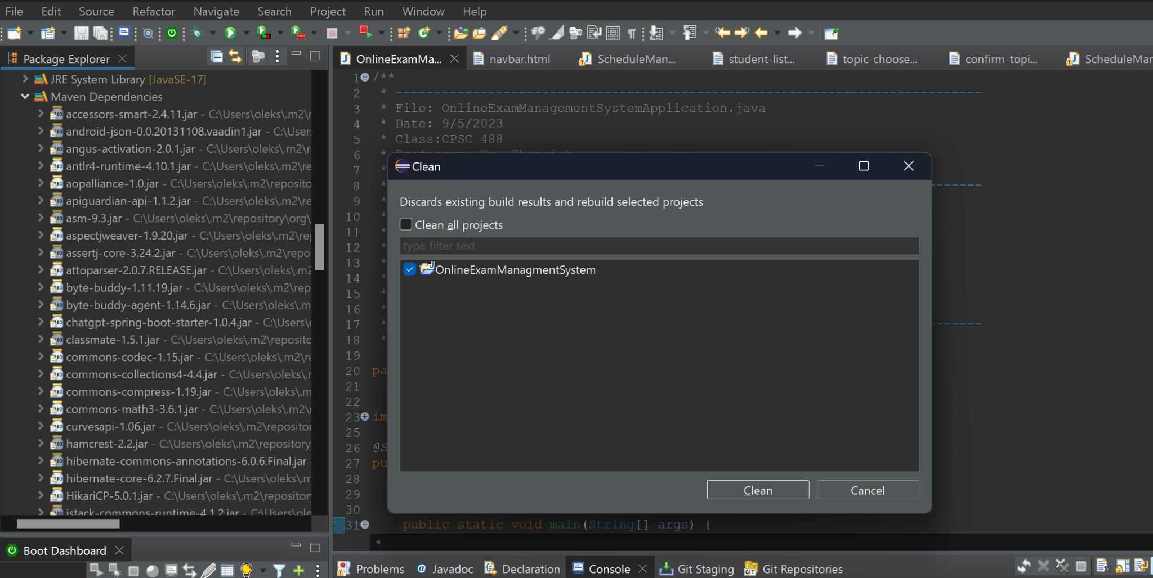

1. Now, the program should be good to run with no errors.

## **Running the Program after Setup**

After getting all the program files open in Eclipse you’ll want to run the program.

1. You’ll need to right click on the top of the files tree, hover over **Run As**, then click Spring Boot Apps

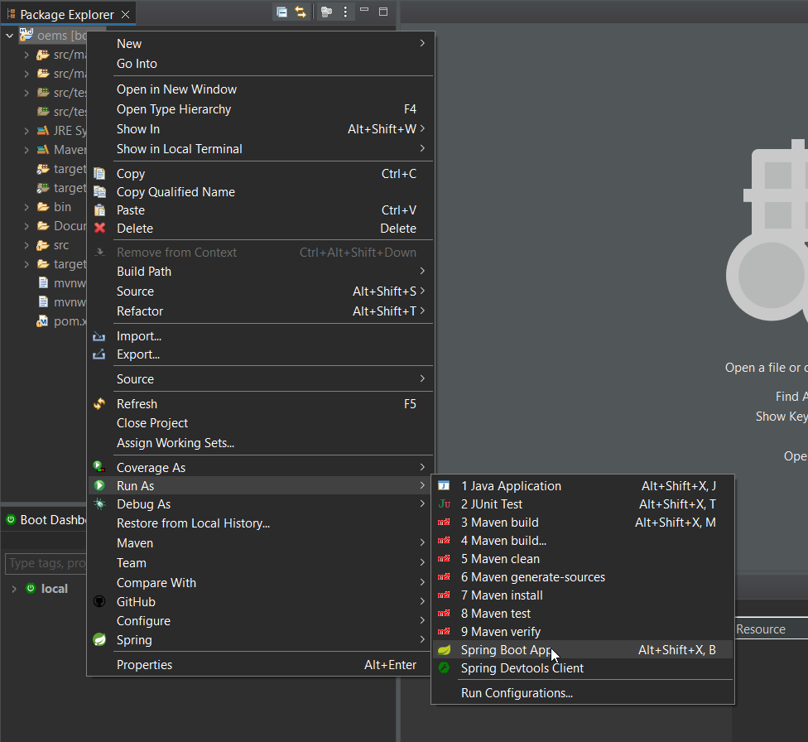

1. You will then need to navigate to your browser of choice and type *localhost:8080* into the url bar. The login page will be displayed.

*user: Root, pass: software*

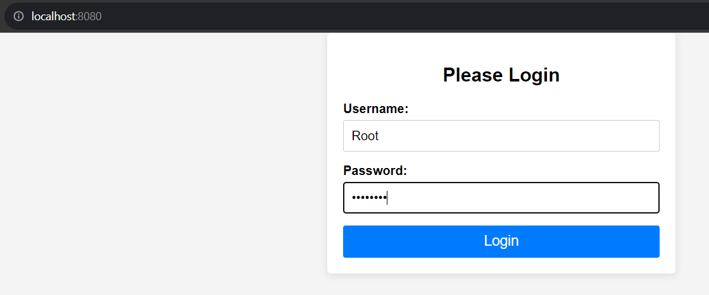

1. After Logging in you will be presented with the Main Screen for an instructor.

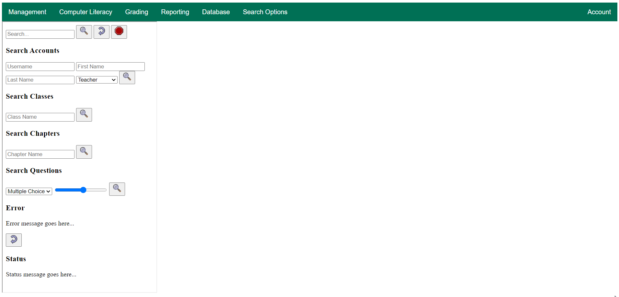

1. You have a navigation bar that has multiple options, the current options that are available are Management, Computer Literacy, Grading, Reporting, Database, Search, Options.
   1. Management has 5 options under it
      1. Accounts - ***Currently Not Functioning***
      2. Create Account - This option will take you to the Registration Form page. You are able to enter user information and click finish to register that user to the database.
      3. Classes - Dropdown menu with classes will appear. The chosen class will be redirected to an examination page. This is still ***under development***
      4. Chapters - This lets the user choose between chapters and different examination forms. This is ***under Development***
      5. Exams - Allows the user to pick a class and get redirected to the exam
   2. Computer Literacy
      1. Exam Generator - ***Currently Not Functioning***
   3. Grading
      1. Exam Grading - ***Currently Not Functioning***
   4. Reporting
      1. Exam information - ***Currently Not Functioning***
      2. IP Address - ***Currently Not Functioning***
   5. Database
      1. View All Students - Routes to an HTML page that shows all students in the database.
      2. Add Students - Routes to an HTML page that allows the admin to add students to the database.
      3. Add Instructors - Routes to an HTML page that allows the admin to add instructors to the database.
      4. Add Courses- Routes to an HTML page that allows the admin to add courses to the database.
      5. Assign Students - Allows the admin to assign existing students to existing classes
         1. The association will be recorded and uploaded to the student_and_courses table
      6. Assign Instructors- Allows the admin to assign existing instructors to existing classes
         1. The association will be recorded and uploaded to the instructor_courses table
      7. Export to Excel - Exports the students from the database to your local drive as an excel file. By default, it should be downloaded to your ‘Downloads’ folder
      8. Import with Excel - Allows an import of an Excel File that uploads students into the database. Checks if usernames are unique.
   6. Search Options
      1. View Details - ***Currently Not Functioning***
   7. Account
      1. Change Password - ***Currently Not Functioning***
      2. Logout - This option will take you back to the login page.

## **A.I. Exam Generation**

1. At the navbar page, hover over **Exam Generation** and click on Generate Exam

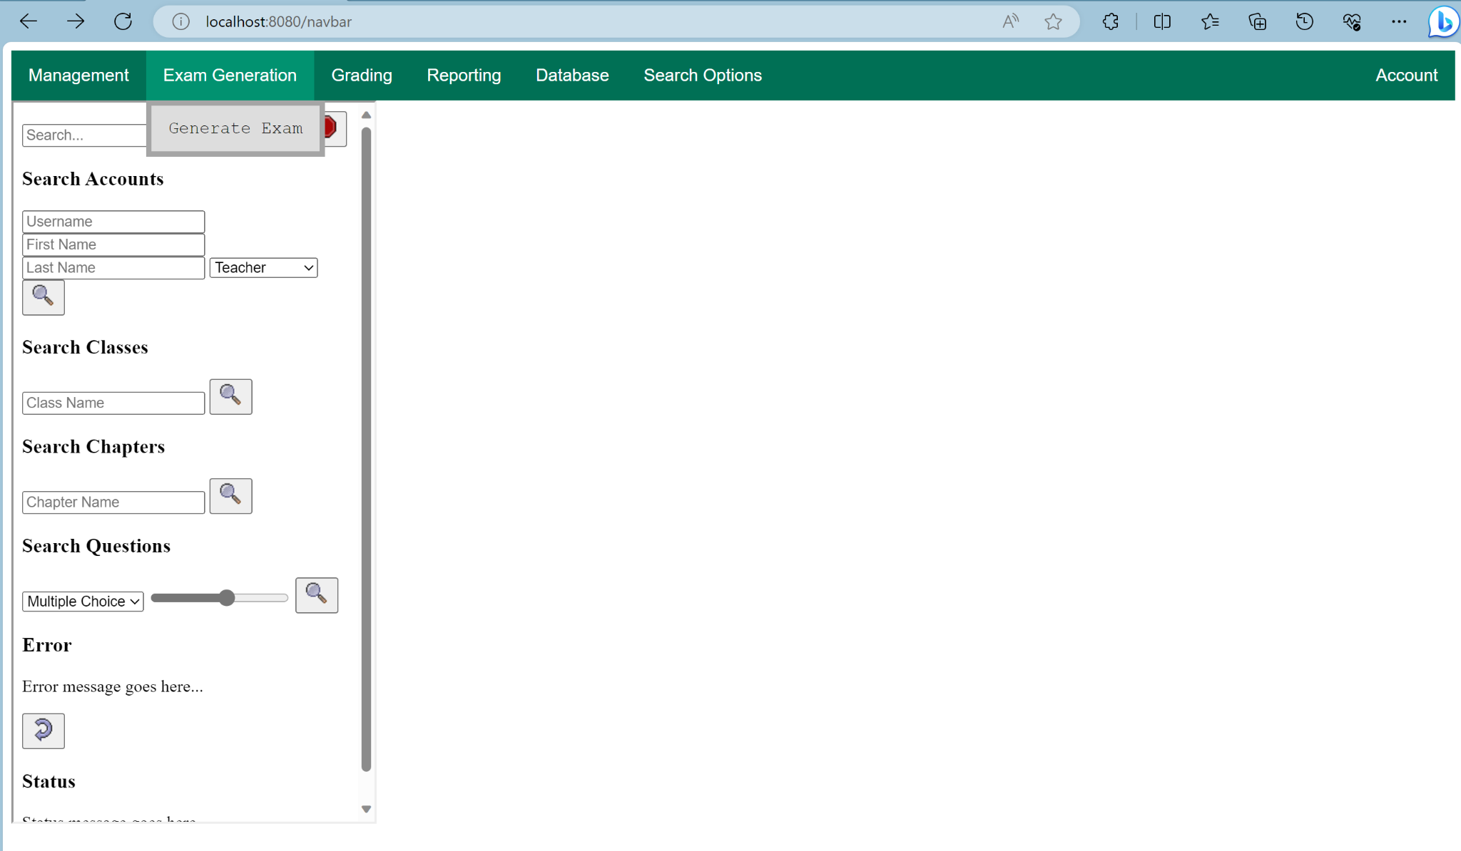

1. You will be met with the following prompt page

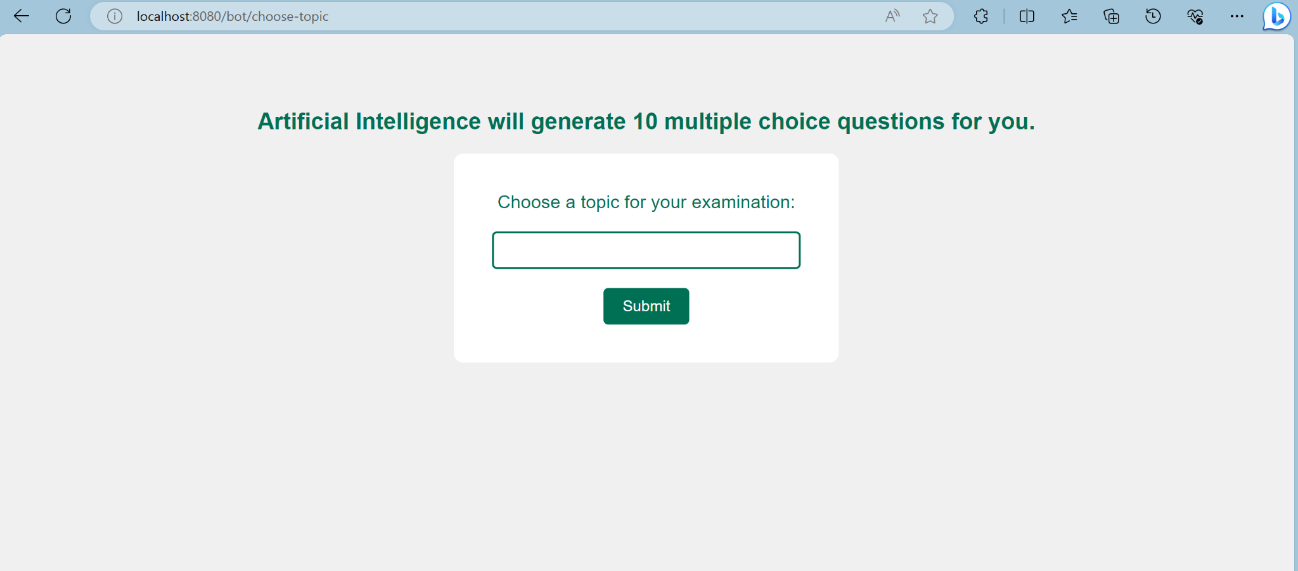

1. Within the prompt box, make sure to write an examination topic of your choice. It can be anything. Click **Submit**
2. You will be met with a confirmation page, click **Yes, proceed** and allow for about 5-10 seconds for the exam to generate itself.

